2013 Summit for Non-Conventional Oil & Gas Cooperation Partners
And Founding Ceremony for Non-Conventional Oil & Gas Industry Confederation

Time: 2013.11.15-16 Location: Beijing

Theme: Together, Promote the Industry

Sponsors
China Energy Net Research Center
Non-Conventional Oil & Gas Industry Confederation

Conference Background

Energy is the pillar for national economy development. Along with the arrival of the continued and rapid economic growth of China and low carbon times, rational development and utilization of non-conventional oil and gas resources is of extreme importance. Non-conventional oil and gas resources means the oil and gas resources that cannot be explored and developed in normal methods and by normal technical means and, the resources generally includes tight sad gas, tight oil, oil sand, oil shale, shale gas, coal-bed methane, and inflammable ice, etc. In June 2013, National Development and Reform Commission issued <<Notice on Adjusting Natural Gas Price (Fa Gai Jia Ge [2013] No. 1246)>>, and the rise of natural gas price has allayed the cost pressure of the exploration and development of non-conventional natural gas, has made a big stride towards market, and has accelerated the exploration and development of the upstream natural gas resources. However, due to the issues that have long been existing in the fields of exploration and development of oil and gas in the process of industrial development, such as long time isolation, obstacles posed by the systems, and incomplete environmental protection and supervision system, the industrial chain shall be improved gradually in future. With the globalization and diffusion and transfer of technologies, China shall be able to grasp the opportunity brought by “Shale Gas Revolution”.
From naming shale gas as an independent mineral type to multi-times` tendering from whole society for bidders for shale gas projects to subsidizing shale gas and to promoting standardization for shale gas industry, Chinese government has tried to push forward a shale gas revolution in China. According to <<The Twelfth-Five Year Plan on Shale Gas>>, by year 2015, the shale gas output in China shall reach 6.5 billion cubic meters; and by year 2020, China will endeavor to push the output to be something between 60 billion – 100 billion cubic meters. By the current progress, the development of shale gas in China is facing certain challenges such as the limited geological knowledge about the shale gas reserve in China and the relevant development technologies; the uncertainty about the investment return on shale gas under the situation dominated by the state oil company; absence of infrastructure and service in shale gas development industrial chain; and the issues concerning land and environment, etc. Issues like how to fast-track the shale gas development through effective competition and by building positive investment mode shall be discussed heatedly in this summit.
The 2013 Summit for Non-Conventional Oil & Gas Cooperation Partners shall be held around the theme “Together, Promote the Industry” and shall aim to promote integration of the businesses in each of the steps of the industrial chain, grasp opportunity, face challenge, accelerate the development process of non-conventional oil and gas commercialization in China, strengthen the exchange both domestic and abroad, conduct in-depth discussions on the frontier, practical, and hot issues such as how to establish financing modes, etc.; share operation and management experience obtained from the current projects in China; enhance the exploration, development and utilization of shale gas in China; and further promote market-oriented industrial development.

Conference Features:
About the Conference
● Authoritative Experts from the National Bureau of Energy, Ministry of State Land and Resources, Development & Research Center of the State Council, China Oil, SinoPec, China Offshore Oil, and Huadian Power Engineering, etc. to analyze the policies and growth impetus on Chinese non-conventional oil and gas industry.
● Precise Positioning: Focus on the hot spots of the industrial development and summit theme, and the people to the summit come from whole industrial chain, try to build a platform for in-depth exchange and exhibition among businesses and cooperation partners.
● Win-Win by Cooperation: the non-conventional oil and gas industrial confederation shall be established during the summit, to think together, work together, display synergy, discuss future development strategy together, and promote the industry together.
Entities Participating in the Conference:

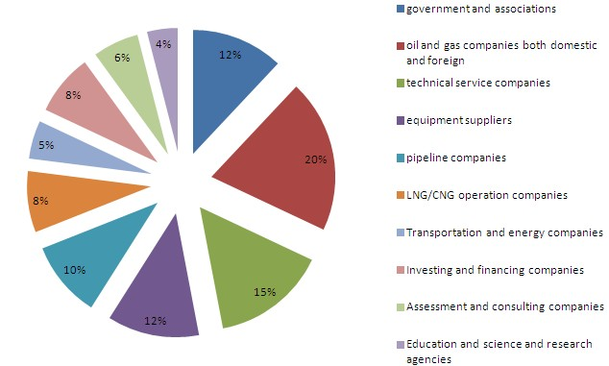

Proposed Agenda
2013 Summit for Non-Conventional Oil & Gas Cooperation Partners and
Founding Ceremony for Non-Conventional Oil & Gas Industry Confederation
Day 1 | Opening ceremony for the summit; Ceremony for the Establishment of the Confederation
Morning | Subjects for Discussion: The steps of the whole industrial chain and the relevant business mode and market opportunity including exploration, design, and development in early stage; upstream production step; mid-stream storage and transportation; downstream application.
Morning | Latest developments and prospects of global non-conventional oil and gas
Morning | The impact of the third industrial revolution brought by the American shale gas revolution
Morning | The challenge and opportunity faced by the development of Chinese non-conventional oil and gas industry
Morning | Industrial chain analysis and comparative analysis of the situations between China and US
Morning | Investing and financing mode for non-conventional oil and gas: business mode and investment risks analysis
Afternoon | Liberate production capacity surplus: build service platform for non-conventional oil and gas businesses
Afternoon | Learn from Sulige: project management experience on non-conventional oil and gas development
Afternoon | Historical reference: the impact of industrial policy to coal-bed methane
Afternoon | Guarantee for success: build a long-term supervision mechanism for environment and safety process.
Afternoon | Round-table Dialogue: The development of non-conventional oil and gas depends on the oil and gas market reform process
Day 2 | Close door discussion by the members of the confederation
Morning | Distinguished guests:  Confederation Council (relevant leaders and the representatives from member entities. The member entities come from the businesses of the upstream, mid-stream, and downstream industrial chain and the steps of equipment, service, circulation, and finance)  Confederation Expert Committee and Investment Committee (related government officials and senior experts in the industry)
Morning | Self-introduction by the members of the confederation (Company brief introduction and main business, and purpose of joining in the confederation, etc.)
Morning | Dialogue between members of the confederation and government administrative agencies: issues and obstacles faced by the participating businesses, solutions or policy suggestions (mining right transfer, exit mechanism, etc.)
Morning | Discussion on next-step working plan by Confederation Council, Expert Committee, and Investment Committee.
Morning | Exchange among members
（The list is in random order）
Proposed Distinguished Guests to be Invited

Chen Qingtai, Development Research Center of the State Council senior researcher
Fu Chengyu, China Petroleum and Chemical Group co., LTD chairman、Party secretary
Hu Wenrui, Academician of Chinese Academy of Science
Qiu Zhongjian,The Chinese academy of engineering 、Chairman of Chinese petroleum society
Jiang Yunbao,Vice Chairman of China Industry Development Association

Yang Lei, Deputy Secretary for Oil and Gas Department Department of National Energy Administration
Ding Zhimin, Deputy Director of Policies and Regulations Department of National Energy Administration
Liu Hongzhi,Deputy Director of Science and Technology Department of Ministry of Environmental Protection
Zhang Dawei,Director of Mineral Resources Reserves Evaluation Center at MLR
Li hang,The central financial leading group, Director of the office
Li Cheng, deputy director of Ministry of Finance of the People’s Replublic of China economic construction Energy policy in
Li Yuxi, Researcher of Oil and Gas Resources Strategic Research Center at Ministry of Land and Resources

Zhang Yongwei, Researcher at State Council Development Research Center
Zeng Xingqiu, Former General Manager of Sinochem International Petroleum Exploration and Development Co., Ltd.
Zhang Kang, Deputy Director of Advisory Committee of Sinopec Petroleum Exploration and Development Research Institute
Xu Bo, Senior Economist of CNPC Economic and Technical Research Institute
Gao ruimin, The dean of Research Institute of Yanchang petroleum(group)co.ltd
Liu Honglin ,Research Institute of Petroleum Exploration＆ Development Langfang branch of new energy research institute, deputy director
Wang Lansheng, DirectorPetroChina Southwest Oil & Gasfield Company Exploration and development research institute analysis experiment center
Chen Weidong, Chief Energy Researcher of China National Offshore Oil Corporation
Dong Xiucheng, Director of Oil And Gas Industry Development Research Center of China University of Petroleum

Xie chunwang China huadian engineering (group) co., LTD ,vice general manager
Meng Shangzhi, Senior engineer of China United Coalbed Methane Co., Ltd. The development of the production department
ZhangFengwu ,Chairman of Chong Qing Mineral Resources Development Co.Ltd Zhang Mi, Chairman of the Honghua Group Limted board
Wei Hong, general manager of Xinjiang Guanghui Oil co., LTD
Wang jingbo, chairman of Titan Gas Technology

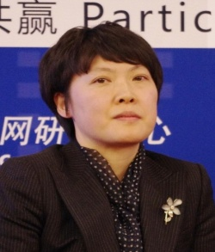  Distinguished Guests Who Delivered Speeches in past Summits |  | 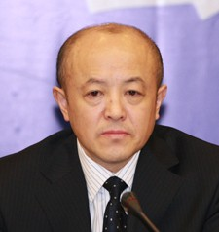 |  | 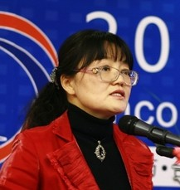
LiuHong,Deputy Director of Oil And Gas Department of National Energy Administration |  | Zhang Dawei,Director of Mineral Resources Reserves Evaluation Center at MLR |  | LiuHongzhi,DeputyDirector of Science and Technology Department of Ministry of Environmental Protection
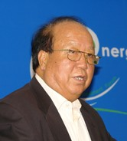 |  | 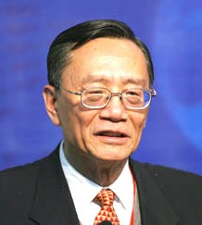 |  | 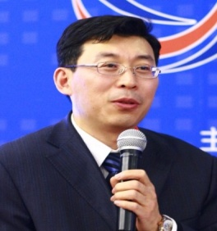
HuWenrui, Academician of Chinese Academy of Science |  | Zeng Xingqiu, Former General Manager of Sinochem International Petroleum Exploration and Development Co., Ltd. |  | ZhangYongwei,Researcher at State Council Development Research Center
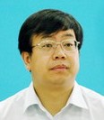 |  | 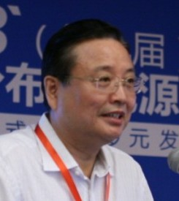 |  | 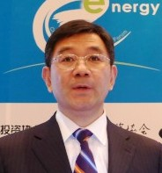
Zheng Jiangling,China huadian engineering (group) co., LTD ,vice general manager |  | Chen Feng, Executive Vice Chairman of Chinese Institute of Electrical Engineering |  | Miao xinshan ,deputy director general china development bank large corporate client department
 |  | 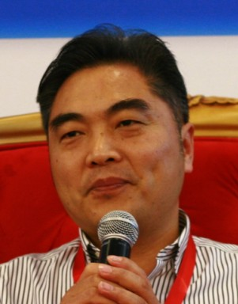 |  | 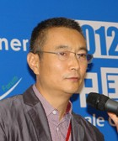
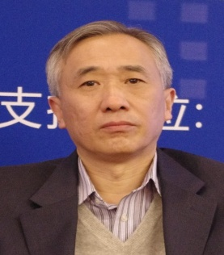
Guo Hua, VP of Guodian New Energy Technology Research Institute |  | ZhangFengwu ,Chairman of Chong Qing Mineral Resources Development Co.Ltd |  | Lin dongliang,Partner of IDG Capital
Please complete the following information and fax the registration form to us, so we can make proper arrangement.
Registration Form

Company Name
Address |  |  |  | Zip Code
Contact Name |  |  |  | Position
Mobile phone |  |  |  | E-mail
Invoice name
Invoice content |  | □Technical Service Fee □Consulting Services Fee □Information Service Fee □Service Fee □Conference Service Fee
Participant Name |  | Department | Position | Mobile phone  (Required) | E-mail
Participant Cost |  | Fee: 6500 RMB/Person for day 1 (including conference materials, beverage and tea break) .  For non-member of the confederation of non-conventional oil and gas industry: 10,000 RMB/Year (Service refer to attachment)  Total ______ people of the entity attend the conference, total fees: (RMB___Yuan)
Accommodation |  | The organizing committee has reserved some rooms for participants at the following hotels and participants to the conference shall enjoy special discounts.  The number of the rooms reserved is limited, and should you want to reserve, please contact with the hotel before November 15, 2013 by mentioning that you will participate in the “2013 Summit for Non-Conventional Oil & Gas Cooperation Partners” to be conducted by China Energy Net.
Payment | Remittance | Full name of the payee: China Energy Net Consulting Co., Ltd  北京中能网讯咨询有限公司  Bank: Beijing Baiyun Road Branch of Industrial and Commercial Bank of China (ICBC Baiyun Road Branch)  Bank Account: 020 002 001 920 090 0532
Inquiries |  | Contact:  Inquiring Number: 010－51915030  Fax: 010－51915237  E-mail: @china5e.com  Website: www. china5e.com

